The following steps should be taken to use the CivicEngage APIs.

CivicEngage uses REST APIs. REST APIs are available for V5/Aurora Only. These REST APIs are built into every Aurora CivicEngage site.

Developers can use the REST APIs via Zapier or by writing your own connector.

API | REST (V5/Aurora only)
Alert Center | X*
Authentication | X
Calendar | X*
CMS | X
Citizen Request Tracker (CRT) | X
Document Center | X
Facilities | X
Form Center | X
NewsFlash | X*
Pages | X
Subscriber Management | X

*A connector for these APIs are available via the Zapier web automation tool.

Appendix A - Connecting with Zapier
Appendix B – Connecting without Zapier

Appendix A – Connecting with Zapier

A free connector is available via the Zapier web automation tool (can be used for Alert Center, Calendar and NewsFlash APIs).

- Developers should go to zapier.com/zapbook/civicengage to download the connector.

- Developers will be prompted to create a free trial account. Select Sign up FREE today.

- Search for CivicEngage in search bar. When the CivicEngage App details appear, select Connect Account.

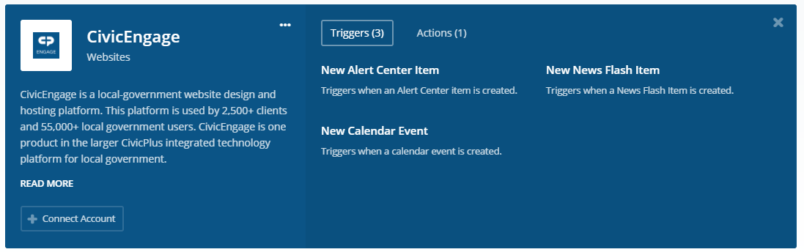

- Developer will be redirected to a CivicPlus Sign In screen. Developer is prompted for site name and CivicEngage user credentials (user must have permissions to perform intended API actions). Slowly type the first three letters of your organization and wait for a site dropdown to appear (ex. The City of Manhattan would type M-A-N….and wait for the dropdown to show Manhattan, KS; then select your organization’s site). Once you have information populated, select SIGN IN.
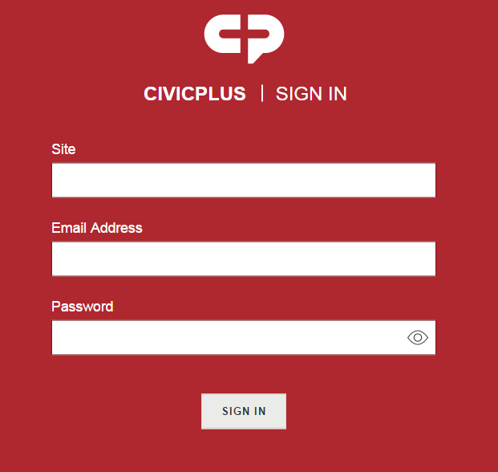

- After selecting Sign In, an Authorize screen appears. Select Authorize.
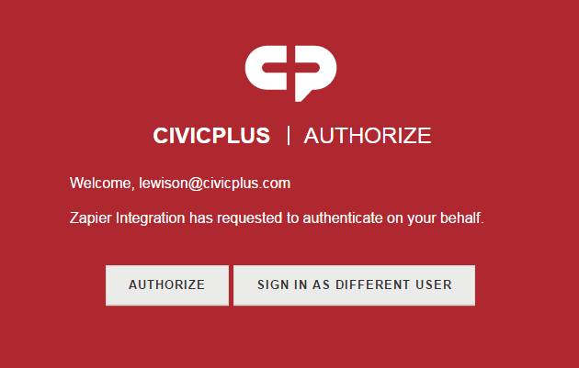

- The CivicEngage logo will appear and will show a checkmark next to Account Connected.

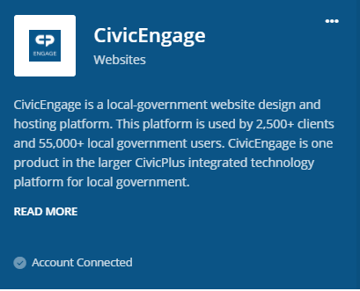

- Select the three dots (…) in the top right corner of the CivicEngage box and select Make a Zap.
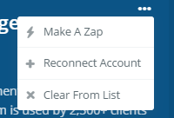

- Select CivicEngage from Your Apps.
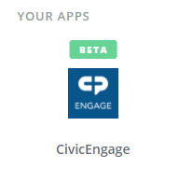
- Select the CivicEngage Trigger that you want to use (ex. Alert Center, NewsFlash or Calendar). Then select Save + Continue.
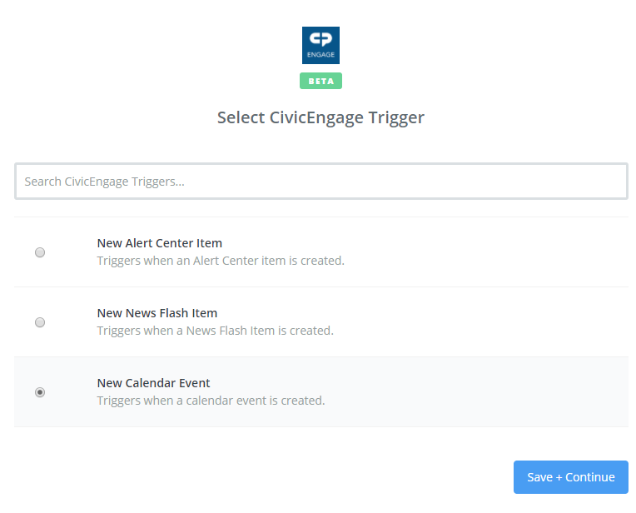
- Select the Account you want to use. You can also select TEST if you want to ensure it is connected.
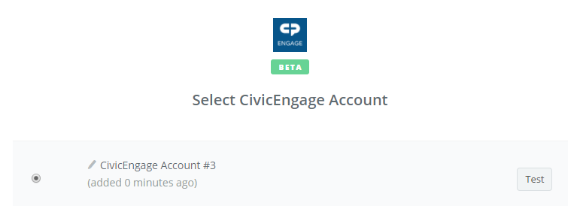

- Select the category that you want to connect. 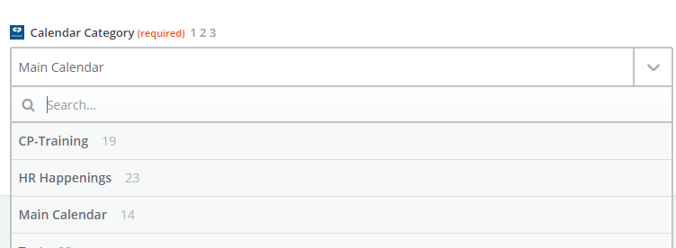

- Select Fetch & Continue.
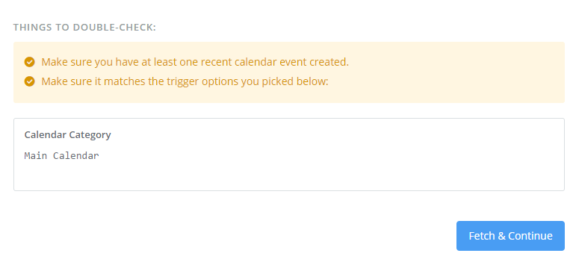

- Once your screen says Test Successful, select Continue.
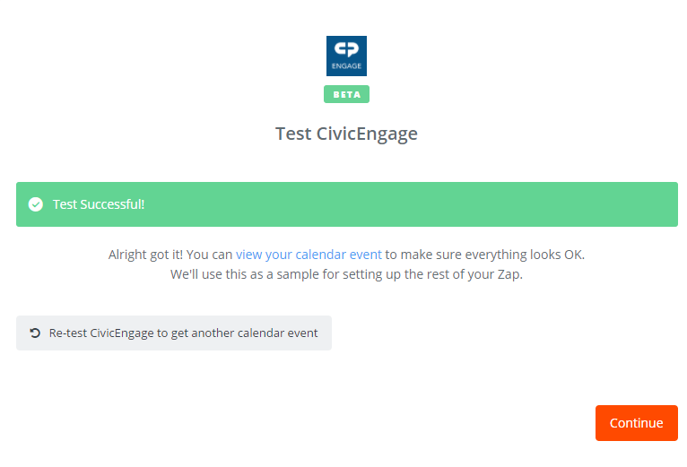

- Select the App that you want to connect to (for instance, you might want to search for and select Google Calendar, if you want to connect a google account to a CivicEngage account).
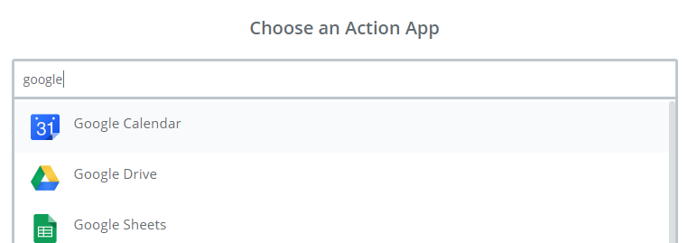

- Select the action you want to take on that app. (Note: This will be different per app).
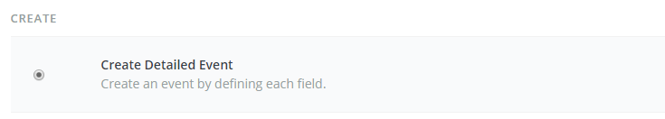

- Once you have selected the action you want to take on that app, select Save + Continue.

- Zapier will “call” the app you are trying to log into. You will be prompted to select your account (Note: this could be different per app that you are connecting to). Select Continue. You might also be prompted for Zapier to have access to that account. Select Allow.
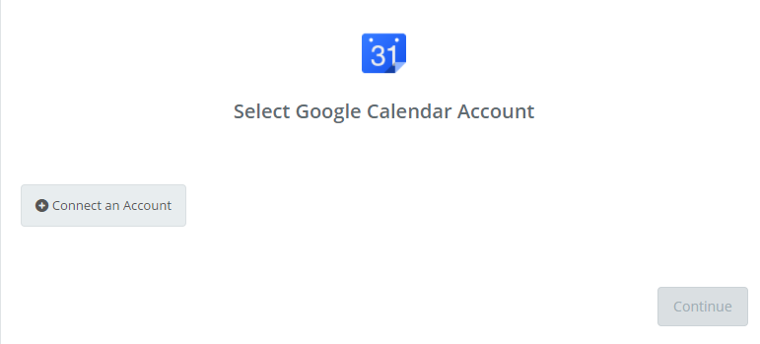
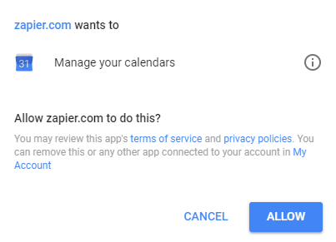

- Once connected to an account, select Save + Continue.

- You will be prompted to fill in the fields you want to connect between apps. This is explaining to Zapier which fields you want to match. (Ex. CivicEngage Description matches to Google Calendar Summary). (Note: this will be different for each app). Once you have matched the fields, select Continue.
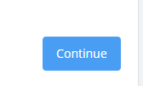

- You will see a summary of all fields that will be pulled/pushed from one app to another. Select Create & Continue.
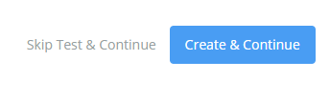

- You will see a screen exclaiming Test Successful. You can now select Finish. You apps will now be connected.

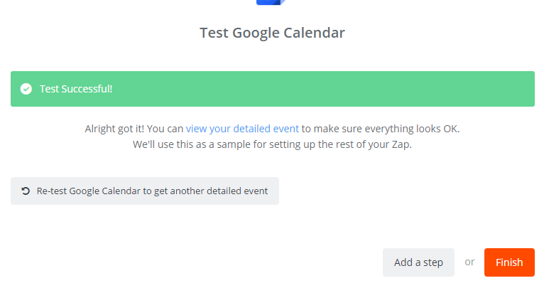

- Name your Zap, then select the toggle switch to On. (Note: new information is retrieved every 5 minutes. It might take that long to populate information between apps).
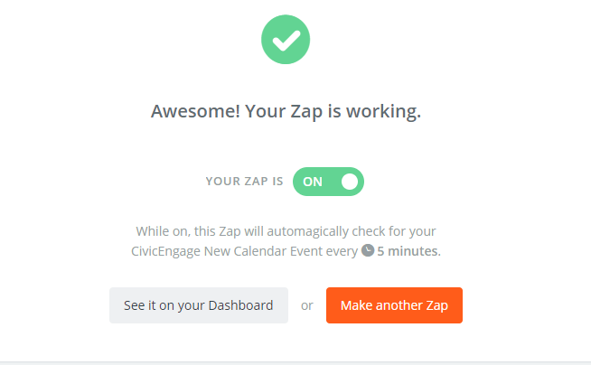

Appendix B – Connecting without Zapier

If developers choose not to use Zapier, follow these steps.

- Developers can find APIs by typing https://Site_nameSSLDomain/api (replacing "SSLDomain" with site’s secure domain).

- Contact support@civicplus.com to obtain authentication API Key and Partition.

- Go to the Authentication API and expand /api/Authentication/vi1/Authenticate.

- Enter user credentials and click Do it! This will return the UserToken (says “APIKey” in Response Body section) which you must enter into the “UserToken” field at the top of the screen.

- Once Partition, UserToken and API Key are entered, the user will be able to use the API.

